Full Stack Development
Lab 2-2-2026

Name:Aditya K U
Roll:AV.SC.U4AIE23001
AIE-A
Part A — Callbacks
=================
Task 1:
Write a program that:
Simulates downloading a file (takes 2 seconds).
After download completes, display "File downloaded" using a
callback function.
HTML Code
<!DOCTYPE html>
<html lang="en">
<head>
<meta charset="UTF-8">
<meta name="viewport" content="width=device-width, initial-scale=1.0">
<title>Document</title>
</head>
<body>
<script src="Callback-1.js"></script>
</body>
</html>
JS Code
function downloadFile(callback) {
console.log("Downloading file...");
setTimeout(function () {
callback();
}, 2000);
}
function onDownloadComplete() {
console.log("File downloaded");
}
downloadFile(onDownloadComplete);
Output:
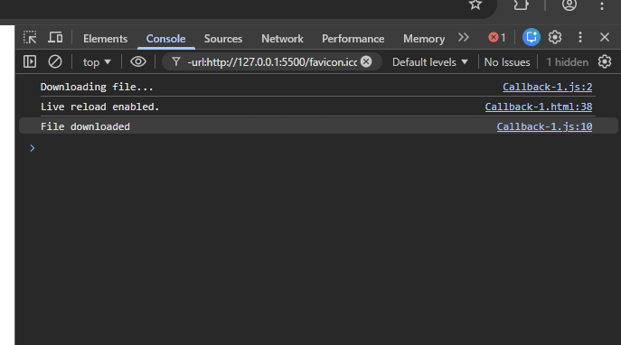
Task 2:
Write a program that:
Has a function to boil water (takes 3 seconds).
Once water is boiled, call another function to make tea
using a callback.
HTML Code
<!DOCTYPE html>
<html lang="en">
<head>
<meta charset="UTF-8">
<meta name="viewport" content="width=device-width, initial-scale=1.0">
<title>Document</title>
</head>
<body>
<script src="Callback-2.js"></script>
</body>
</html>

JS Code
function boilWater(callback) {
console.log("Boiling water...");

setTimeout(() => {
console.log("Water is boiled!");
callback();
}, 3000);
}

function makeTea() {
console.log("Making tea...");
console.log("Tea is ready! ☕");
}

boilWater(makeTea);

Output:
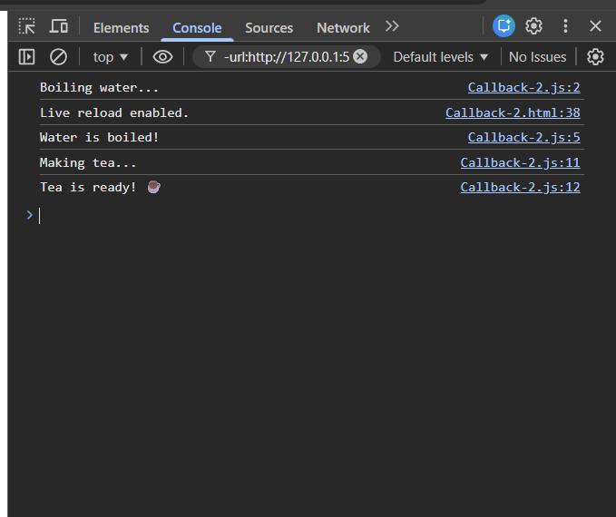
Part B — Promises
===================
Task 3:
Write a program that:
Simulates checking exam results.
If the result is passed, resolve the promise with "You passed!".
If failed, reject the promise with "You failed, try again.".
HTML Code
<!DOCTYPE html>
<html lang="en">
<head>
<meta charset="UTF-8">
<meta name="viewport" content="width=device-width, initial-scale=1.0">
<title>Document</title>
</head>
<body>
<script src="Promises-3.js"></script>
</body>
</html>

JS Code
function checkExamResult(score) {
return new Promise((resolve, reject) => {
console.log("Checking exam result...");

setTimeout(() => {
if (score >= 50) {
resolve("You passed!");
} else {
reject("You failed, try again.");
}
}, 2000);
});
}

checkExamResult(65)
.then((message) => {
console.log(message);
})
.catch((error) => {
console.log(error);
});

Output:
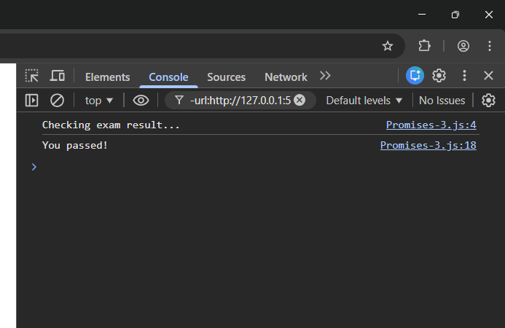
Task 4:
Write a program that:
Simulates booking a train ticket.
Use .then() and .catch() to handle promise result:
Resolve: "Ticket booked successfully"
Reject: "Ticket booking failed"
HTML Code
<!DOCTYPE html>
<html lang="en">
<head>
<meta charset="UTF-8">
<meta name="viewport" content="width=device-width, initial-scale=1.0">
<title>Document</title>
</head>
<body>
<script src="Promises-4.js"></script>
</body>
</html>
JS Code
function bookTrainTicket(isAvailable) {
return new Promise((resolve, reject) => {
console.log("Processing ticket booking...");

setTimeout(() => {
if (isAvailable) {
resolve("Ticket booked successfully");
} else {
reject("Ticket booking failed");
}
}, 2000);
});
}

bookTrainTicket(true)
.then((message) => {
console.log(message);
})
.catch((error) => {
console.log(error);
});

Output:
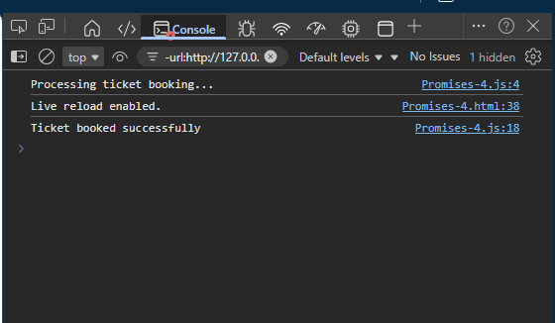
Part C — Async & Await
==========================
Task 5:
Write a program that:
Uses async and await to simulate ordering pizza.
It should:
Wait 2 seconds to prepare pizza.
Print "Pizza ready!"
Then print "Delivering pizza".
HTML Code
<!DOCTYPE html>
<html lang="en">
<head>
<meta charset="UTF-8">
<meta name="viewport" content="width=device-width, initial-scale=1.0">
<title>Document</title>
</head>
<body>
<script src="Async-Await-5.js"></script>
</body>
</html>

JS Code
function preparePizza() {
return new Promise((resolve) => {
console.log("Preparing pizza...");

setTimeout(() => {
resolve("Pizza ready!");
}, 2000);
});
}

async function orderPizza() {
const message = await preparePizza();
console.log(message);
console.log("Delivering pizza");
}

orderPizza();
Output:
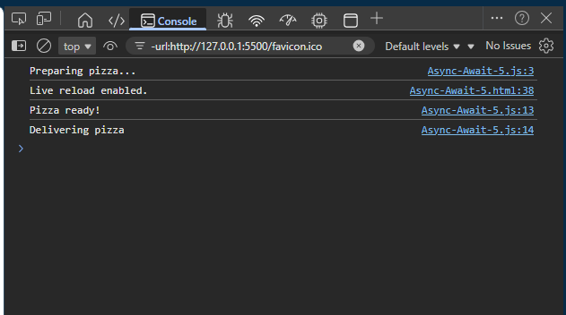

Task 6:
Write a program that:
Defines a function getData() that returns a promise
resolving with "Data received" after 1 second.
Use an async function to call getData() and log the result.
HTML Code
<!DOCTYPE html>
<html lang="en">
<head>
<meta charset="UTF-8">
<meta name="viewport" content="width=device-width, initial-scale=1.0">
<title>Document</title>
</head>
<body>
<script src="Async-Await-6.js"></script>
</body>
</html>

JS Code
function getData() {
return new Promise((resolve) => {
setTimeout(() => {
resolve("Data received");
}, 1000);
});
}
async function fetchData() {
const result = await getData();
console.log(result);
}
fetchData();

Output:
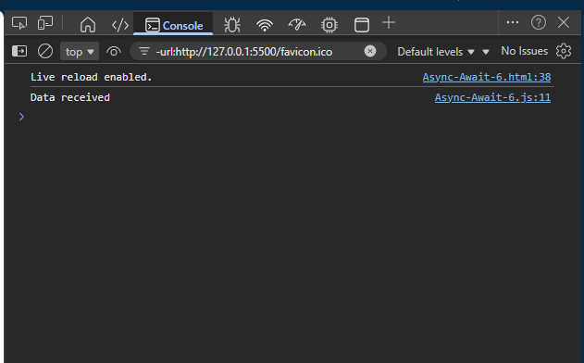

Program 1: Simulating a File Download with Callbacks
=====================================================
Aim: To practice using callbacks to handle asynchronous file download
simulation.
Task Description:
====================
=>Create a function that simulates downloading a file
(use setTimeout to mimic a delay of 3 seconds).
=>Pass a callback function that executes after the download completes,
displaying the file name and size (e.g., "file.txt", 5MB).
=>Write a second callback to log a message confirming the file was saved
to a folder.
=>Test the program by calling the download function with different file
names and sizes.
Challenge: Add error handling if the file size is negative or invalid.

HTML Code
<!DOCTYPE html>
<html lang="en">
<head>
<meta charset="UTF-8">
<meta name="viewport" content="width=device-width, initial-scale=1.0">
<title>Document</title>
</head>
<body>
<script src="Program-1.js"></script>
</body>
</html>

JS Code
function downloadFile(fileName, fileSize, onComplete, onSave) {
console.log(`Starting download of ${fileName}...`);

if (typeof fileSize !== "number" || fileSize <= 0) {
console.log("Error: Invalid file size.");
return;
}

setTimeout(() => {
console.log(`Download complete: ${fileName} (${fileSize}MB)`);

if (typeof onComplete === "function") {
onComplete(fileName, fileSize);
}

if (typeof onSave === "function") {
onSave(fileName);
}

}, 3000);
}

function showFileDetails(name, size) {
console.log(`File Details -> Name: ${name}, Size: ${size}MB`);
}

function confirmSave(name) {
console.log(`${name} has been saved to the Downloads folder.`);
}

downloadFile("file.txt", 5, showFileDetails, confirmSave);
downloadFile("image.png", 10, showFileDetails, confirmSave);
downloadFile("invalid.doc", -3, showFileDetails, confirmSave);

Output
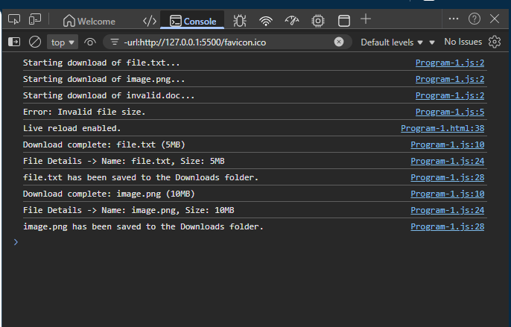

Program 2: Fetching Student Data with Promises
===============================================
Aim: To practice creating and resolving Promises for fetching student
data.
Task Description:
=================
=>Write a function that returns a Promise to fetch student
data (e.g., roll number and name) after a 2-second delay.
=>If the roll number is valid (e.g., positive), resolve the Promise
with the student object; otherwise, reject it with an error message.
=>Consume the Promise using .then() to display the student data
and .catch() to handle errors.
=>Test with both valid and invalid roll numbers.

Challenge: Chain another Promise to fetch the student’s grades based
on the roll number.
HTML Code
<!DOCTYPE html>
<html lang="en">
<head>
<meta charset="UTF-8">
<meta name="viewport" content="width=device-width, initial-scale=1.0">
<title>Document</title>
</head>
<body>
<script src="Program-2.js"></script>
</body>
</html>

JS Code
function fetchStudentData(rollNumber) {
return new Promise((resolve, reject) => {
console.log("Fetching student data...");

setTimeout(() => {
if (typeof rollNumber === "number" && rollNumber > 0) {
resolve({
rollNumber: rollNumber,
name: "John Doe"
});
} else {
reject("Invalid roll number. Please enter a positive number.");
}
}, 2000);
});
}

function fetchStudentGrades(rollNumber) {
return new Promise((resolve) => {
console.log("Fetching student grades...");

setTimeout(() => {
resolve({
rollNumber: rollNumber,
grades: ["A", "B+", "A-"]
});
}, 1500);
});
}

fetchStudentData(101)
.then((student) => {
console.log("Student Data:", student);
return fetchStudentGrades(student.rollNumber);
})
.then((grades) => {
console.log("Student Grades:", grades.grades);
})
.catch((error) => {
console.log("Error:", error);
});

fetchStudentData(-5)
.then((student) => {
console.log("Student Data:", student);
return fetchStudentGrades(student.rollNumber);
})
.then((grades) => {
console.log("Student Grades:", grades.grades);
})
.catch((error) => {
console.log("Error:", error);
});

Output
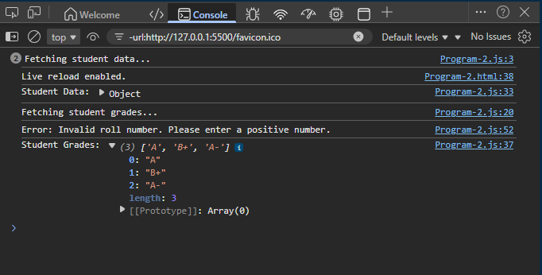

Program 3: Sequential API Calls with Promise Chaining
=======================================================
Aim: To practice chaining Promises to perform sequential asynchronous
operations.
Task Description:
===============

=>Create two functions: one that returns a Promise to fetch a user’s
profile (e.g., user ID and name) and another to fetch their course
list based on the user ID.
=>Use setTimeout to simulate API delays (e.g., 1 second for profile,
2 seconds for courses).
=>Chain the Promises to first fetch the profile and then the
course list, displaying both results.
=>Include error handling for cases where the user ID is invalid.

Challenge: Add a third Promise to fetch course details
(e.g., course name and credits) for one of the courses.

HTML Code
<!DOCTYPE html>
<html lang="en">
<head>
<meta charset="UTF-8">
<meta name="viewport" content="width=device-width, initial-scale=1.0">
<title>Document</title>
</head>
<body>
<script src="Program-3.js"></script>
</body>
</html>

JS Code
function fetchUserProfile(userId) {
return new Promise((resolve, reject) => {
console.log("Fetching user profile...");

setTimeout(() => {
if (typeof userId === "number" && userId > 0) {
resolve({
userId: userId,
name: "Alice"
});
} else {
reject("Invalid user ID. Please provide a positive number.");
}
}, 1000);
});
}

function fetchUserCourses(userId) {
return new Promise((resolve) => {
console.log("Fetching user courses...");

setTimeout(() => {
resolve({
userId: userId,
courses: [101, 102, 103]
});
}, 2000);
});
}

function fetchCourseDetails(courseId) {
return new Promise((resolve) => {
console.log("Fetching course details...");

setTimeout(() => {
resolve({
courseId: courseId,
courseName: "JavaScript Basics",
credits: 3
});
}, 1500);
});
}

fetchUserProfile(1)
.then((profile) => {
console.log("User Profile:", profile);
return fetchUserCourses(profile.userId);
})
.then((courseData) => {
console.log("Course List:", courseData.courses);
return fetchCourseDetails(courseData.courses[0]);
})
.then((courseDetails) => {
console.log("Course Details:", courseDetails);
})
.catch((error) => {
console.log("Error:", error);
});

fetchUserProfile(-1)
.then((profile) => {
console.log("User Profile:", profile);
return fetchUserCourses(profile.userId);
})
.then((courseData) => {
console.log("Course List:", courseData.courses);
return fetchCourseDetails(courseData.courses[0]);
})
.then((courseDetails) => {
console.log("Course Details:", courseDetails);
})
.catch((error) => {
console.log("Error:", error);
});

Output
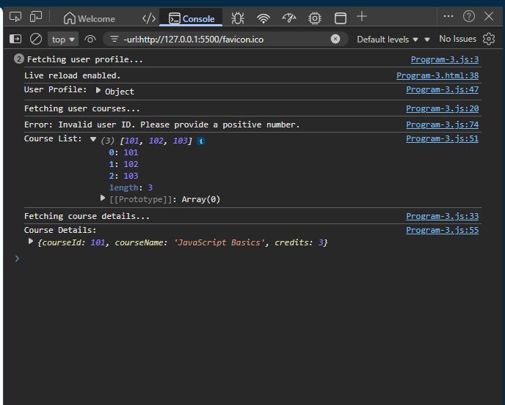
Program 4: Fetching Library Books with Async/Await
==================================================
Aim: To practice using async/await for cleaner asynchronous code.
Task Description:

=>Write a function that returns a Promise to fetch book details
(e.g., book ID, title, and availability) after a 1-second delay.
=>Create an async function that uses await to fetch details of a
single book and display its title and availability status.
=>Use a try/catch block to handle errors if the book ID is invalid.
=>Test with multiple book IDs, including one that fails.

Challenge: Modify the function to fetch details of two books
sequentially and display both results.

HTML Code
<!DOCTYPE html>
<html lang="en">
<head>
<meta charset="UTF-8">
<meta name="viewport" content="width=device-width, initial-scale=1.0">
<title>Document</title>
</head>
<body>
<script src="Program-4.js"></script>
</body>
</html>

JS Code
function fetchBookDetails(bookId) {
return new Promise((resolve, reject) => {
console.log(`Fetching details for Book ID: ${bookId}...`);

setTimeout(() => {
if (typeof bookId === "number" && bookId > 0) {
resolve({
bookId: bookId,
title: `Book Title ${bookId}`,
available: bookId % 2 === 0
});
} else {
reject("Invalid Book ID. Please provide a positive number.");
}
}, 1000);
});
}

async function displayBook(bookId) {
try {
const book = await fetchBookDetails(bookId);
console.log(`Title: ${book.title}`);
console.log(`Availability: ${book.available ? "Available" : "Not Available"}`);
console.log("---------------------------");
} catch (error) {
console.log("Error:", error);
console.log("---------------------------");
}
}

async function displayTwoBooks(bookId1, bookId2) {
try {
const book1 = await fetchBookDetails(bookId1);
console.log(`Title: ${book1.title}`);
console.log(`Availability: ${book1.available ? "Available" : "Not Available"}`);
console.log("---------------------------");

const book2 = await fetchBookDetails(bookId2);
console.log(`Title: ${book2.title}`);
console.log(`Availability: ${book2.available ? "Available" : "Not Available"}`);
console.log("---------------------------");

} catch (error) {
console.log("Error:", error);
}
}

displayBook(1);
displayBook(2);
displayBook(-5);

displayTwoBooks(3, 4);

Output
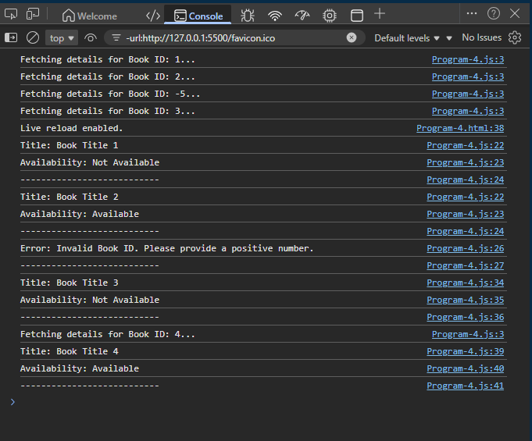

Program 5: Parallel Data Fetching with Promise.all
===================================================
Aim: To practice using Promise.all to handle multiple Promises
concurrently.
Task Description:
=================
=>Create a function that returns a Promise to fetch product
details (e.g., product ID and name) after a random delay (1-3 seconds).
=>Write an async function that uses Promise.all to fetch details of
three products concurrently.
=>Display the results as a list of product names.
=>Include error handling to catch cases where any product ID is invalid.

Challenge: Add a condition where one Promise intentionally rejects to
test error handling.
HTML Code
<!DOCTYPE html>
<html lang="en">
<head>
<meta charset="UTF-8">
<meta name="viewport" content="width=device-width, initial-scale=1.0">
<title>Document</title>
</head>
<body>
<script src="Program-5.js"></script>
</body>
</html>

JS Code
function fetchProduct(productId) {
return new Promise((resolve, reject) => {
const delay = Math.floor(Math.random() * 3000) + 1000;
console.log(`Fetching product ID: ${productId} (delay: ${delay}ms)...`);

setTimeout(() => {
if (typeof productId !== "number" || productId <= 0) {
reject(`Invalid product ID: ${productId}`);
} else if (productId === 2) {
reject(`Product ${productId} is out of stock.`);
} else {
resolve({
productId: productId,
name: `Product ${productId}`
});
}
}, delay);
});
}

async function fetchMultipleProducts(productIds) {
try {
const products = await Promise.all(productIds.map(id => fetchProduct(id)));
console.log("Fetched products:");
products.forEach(p => console.log(`- ${p.name}`));
} catch (error) {
console.log("Error while fetching products:", error);
}
}

fetchMultipleProducts([1, 3, 4]);

fetchMultipleProducts([1, 2, 3]);

Output

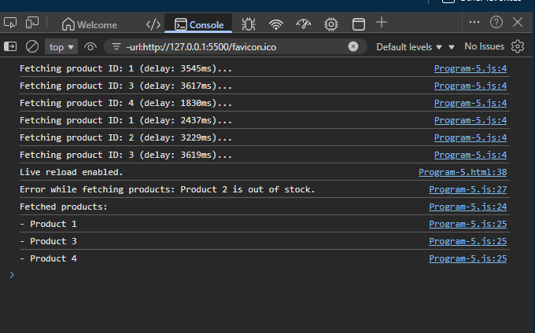

Program 6: Simulating a Login System with Async/Await
======================================================
Aim: To practice error handling in asynchronous operations using
async/await.
Task Description:
=================
=>Create a function that returns a Promise to simulate user
login (e.g., check username and password) with a 1-second delay.
=>Resolve the Promise with a success message if credentials are
valid (e.g., username: "student", password: "pass123"); otherwise,
reject with an error.
=>Write an async function that uses await to call the login function
and display the result.
=>Use try/catch to handle login failures.
=>Test with both valid and invalid credentials.
Challenge: Add a second Promise to fetch user preferences after
a successful login.

HTML Code
<!DOCTYPE html>
<html lang="en">
<head>
<meta charset="UTF-8">
<meta name="viewport" content="width=device-width, initial-scale=1.0">
<title>Document</title>
</head>
<body>
<script src="Program-6.js"></script>
</body>
</html>

JS Code
function loginUser(username, password) {
return new Promise((resolve, reject) => {
console.log("Checking login credentials...");

setTimeout(() => {
if (username === "student" && password === "pass123") {
resolve("Login successful!");
} else {
reject("Invalid username or password.");
}
}, 1000);
});
}

function fetchUserPreferences(username) {
return new Promise((resolve) => {
console.log("Fetching user preferences...");

setTimeout(() => {
resolve({
username: username,
theme: "dark",
notifications: true
});
}, 1500);
});
}

async function userLoginFlow(username, password) {
try {
const loginMessage = await loginUser(username, password);
console.log(loginMessage);

const preferences = await fetchUserPreferences(username);
console.log("User Preferences:", preferences);
console.log("---------------------------");
} catch (error) {
console.log("Error:", error);
console.log("---------------------------");
}
}

userLoginFlow("student", "pass123");
userLoginFlow("student", "wrongpass");
userLoginFlow("guest", "pass123");
Output
